Meta Description:
Video SEO is a great way to optimize your video content to achieve a higher ranking on search engines. In this guide, you will learn everything related to it.
Images:
https://drive.google.com/drive/folders/1J89Qn-jRTvtuqRCiRFm9wCOhS3gKBLix

Comprehensive Guide to Video SEO: Strategies for 2025
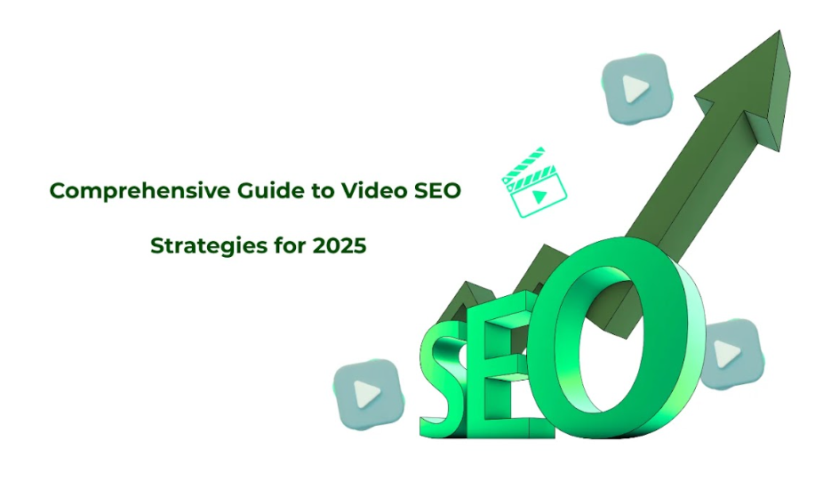
Video content is becoming more and more important among marketers due to its effective role in driving customers' attention.
Here in this guide, we will discuss what Video SEO is, why it is quickly becoming a crucial factor in ranking, and how businesses can use it most efficiently by the year 2025.
Let’s start this guide with the definition and importance of video SEO.

1. Understanding Video SEO: Definition & Importance

What is Video SEO?
Video SEO is a process of optimizing videos for better ranking in search engines and video-sharing platforms. The following are typical aspects that are concerned with Video SEO:
- Tags: This includes the title of your video, the description of the video, the tags, and keywords that the video uses to inform its search engine.
- For evaluation, engagement cultural allied indicators like, comments, shares, and watch time can be of great importance.
- Findability or Visibility: Making it easy for the video to be found by the end-users by being searchable on search engines, social media, and other outreach platforms.

Why Businesses Should Prioritize Video SEO in 2025?
Since the proportion of video messages will grow rapidly by 2026, it will define a large part of the digital environment. That’s why, the companies who focus on video SEO are not only going to enhance the company website ranking but also to enhance the overall performance of their website and increase the conversion ratio. Additionally, it is not wrong to say video content now become the most informative and effective tool for sharing information and brand promotion.

How do Search Engine Rate Video Content?
Search engines consider different factors to rate video content such as watch time ratio, audience engagement, comments, likes and shares, subscribers, etc. The other relevant factors include:
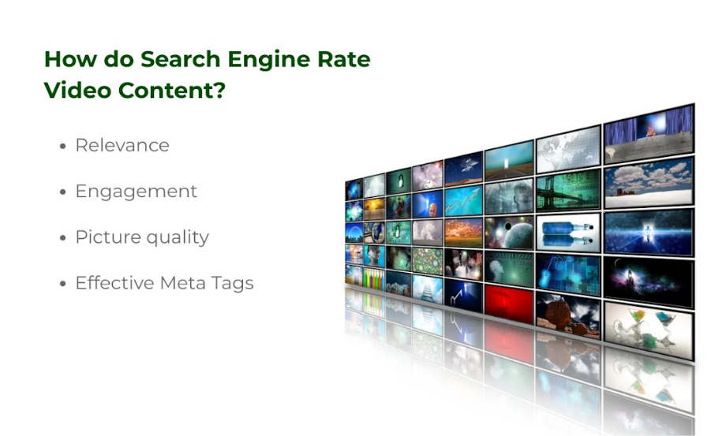
- Relevance: The level of matching shown by the video to the results of a given query.
- Engagement: The higher the engagement signals the better the quality of the content to be expected.
- Picture quality: Determining the resolution, how it was encoded, and the general quality of the whole video.
- Effective Meta Tags: Good and effective titles, descriptions & tags.

Why Video SEO Matters in 2025?

Raise the Dominance of Video in Search Results:
Specifically, by 2025, video content in the search results will be mainly presented on Google, YouTube, and social networks. As most of the search engines rank video high in their search algorithms, businesses that do not do video SEO, lose many organic traffic potentials.

Impact on User Engagement, Dwell Time, and Conversions:
Most visitors tend to have a longer attention span on video materials, which results in the improvement of time spent on site and a decrease in the bounce rate. This benefits the users and also informs the search engines about the uniqueness of the content and increases the rank further. Additionally, the use of videos in engaging your target audience can help boost conversion rates and act as an important strategy to boost business.

2. Does Video Help with SEO?

The Role of Video in Search Rankings:
Video content is vital in enhancing search engine rankings in several ways such as:
- Dwell Time: A video tends to keep the users engaged for many minutes which informs the search engine that your content is useful.
- Bounce Rates: In cutting the bounce rates, the videos affirm the value of the content through the user’s engagement on the site.
- Multimedia Friendly: A positive side for videos is that they are featured more frequently on SERP features such as video carousels and featured snippets.

Key SEO Benefits of Video Content:
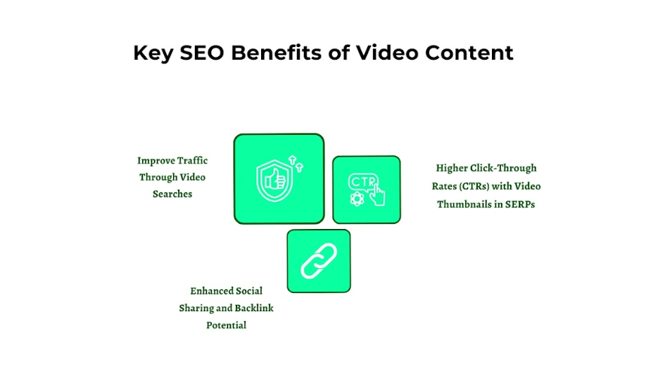

Improve Traffic Through Video Searches:
Optimization of certain videos can help bring a large amount of traffic from the video searches. By creating videos that are suggested by the site to the user, the content increases the company’s visibility by improving its brand recognition and more visits to the site.

Higher Click-Through Rates (CTRs) with Video Thumbnails in SERPs
Attractive thumbnails of the uploaded videos can help your site to grab the attention of the users. Even if people scroll through the results at a fast pace, a well-designed thumbnail can boost your CTR and subsequently, the traffic will increase as well as the rank of your site in the search results.

Enhanced Social Sharing and Backlink Potential:
Sharing of videos is also easy, which makes the content more likely to be shared on social media platforms. This way a lot of backlinks can be created. This way you can get better SEO performance by offering the content more credibility and exposure.

3. 9 Advanced Video SEO Strategies for 2025

With the consumption of video content rising, businesspeople are focusing heavily on video SEO in an attempt to boost traffic, engagement as well as conversions. Below are the techniques that will help create eye-catching videos by bearing in mind the trends and optimization in the year 2025.
1. Optimize for Search Engine Results Pages (SERPs) through Effective Metadata:
Meta tags also have a significant impact concerning the indexing and ranking of a particular piece of your video content. They are titles, descriptions, tags, and other related words that offer context and relatedness. To optimize your videos effectively:
- Choose proper and Keyword-based Video Titles: As with the written material, you have to select engaging titles to highlight your video content. Therefore, make sure the titles should be apt and catchy enough to grab the attention of the users.
- Use Proper Descriptions: Add a proper description of what your video is about in less than 150 characters including keywords in your content description naturally. You should extend the description to make it comprehensible for potential viewers and for search engines as well as to help them understand what they may expect to see in the video.
- Tags Search Wisely: Tags are used to assist the search engines for relating the content of the video and the content of the tags. To rank a page, do not keyword stuff, it is recommended practice to blend both primary and secondary keywords.

2. Utilize Responsive Design for Videos to Cater to Mobile Users.
As mobile traffic occupies a large share of web traffic, its impossibility to exclude videos from mobile optimization is out of the question. Here Responsive design means that the videos are properly crafted to work on any given device in any orientation. Here are some key factors you can consider:

- Adaptive Bitrate Streaming: Always use High-Quality streaming technologies such as HLS or DASH. So, that the quality adjusts according to the device and speed of the connection of the viewer.
- Utilize HTML5 Video Tags: Some of the issues such as viewport and aspect ratio optimization to various devices can be solved.
- Responsive Controls: It is crucial to use a UI design that is friendly for touchscreens to make it easier for users to use the touchpad for controls about the video player.

3. Create High-Quality, Engaging Videos that Effectively Addresses User Intent.
The work of video SEO is based on its essence, which is to create videos that can provide solutions to your audiences’ problems. To achieve this, you need to consider some factors:
- Focus on Users: Perform a keyword research analysis and study the search queries to analyze the mindset of your target audience.
- Value Proposition: Please make sure to make it worthwhile for your users to visit your site whether it is to gain information, or be entertained or motivated. Greet your users always with the questions that have been presenting them in the first place.
- Tell compelling stories: You have to share what gets people on an emotional level so that recognition can be facilitated via storytelling.

4. Promote Videos through Social Media Platforms and Email Marketing.
Promoting the video on social networks and through the email list will surely help increase your site's popularity. Here are some ways to optimize these channels:

- Maximize the Use of Social Media Platforms: Post the videos on such sites as YouTube, Facebook, Instagram, and TikTok. When posting content, always ensure that your content is well suited for the particular platform for which it will be posted.
- Use Email Campaigns: Email marketing is also another effective place where videos can be used to get the attention of the target market. This feature is aimed at increasing the level of relevance of the content that reaches the recipients’ inboxes, as well as their interests.
- Sharing: Make sure to have links to social networks at the bottom of the video and encourage the viewers to share the content.

5. Implement Schema Markup to Enhance Rich Results:
Structured data is an effective way of enhancing the way your videos are represented when using the search option. You can also ensure your viewers are aware of the content that exists outside the video by including structured data in the video in question. Here you can consider the following factors:
- VideoObject Schema: The intended target is to use the VideoObject schema to dramatically enhance your video library, optimization, thumbnail, and duration.
- Rich Snippets: Change to schema to activate rich snippets that can include things such as video, rating, and transcriptions.
- Update the Schema: It is important to update the schema from time to time to suit the changing content in the videos or in the meta-data.

6. Focus on Video Site Speed and Loading Times:
It goes without mentioning that site speed is very important for users as well as for search engine results as well. Since such cases would mean that visitors are forced to watch the videos for long before the content actually loads, most visitors are likely to bounce as they wait for the content to load while watching a video. To optimize site speed:
- Compress the videos: This is an important factor related to the loading time of the website. Why? Because large-sized videos take time to load this cannot be accepted by the modern viewers of the website.
- Implementation of Content Delivery Networks (CDNs): This is a system of distributed servers that help deliver video content faster to users across the globe.
- Lazy Load Videos: It covers the basic technique of lazy load that utilizes techniques to load the videos only when the user scrolls the page down to the videos section.
7. Leverage User-Generated Content for Authenticity and Trust:
UGC acts as a helpful tool when it comes to the figure of authority and gaining trust among your viewers. It is particularly possible to influence the viewers to generate their content with regard to your brand or product. Strategies include:

- Use Contests and Giveaways: Host videos to give users motivation where they are required to produce creative work using the products or services you sell.
- UGC on Your Channels: Add more user-generated videos to the website or social media accounts to bring out the aspect of people using your products.
- Video Comments: Ask customers to provide video comments as a form of feedback to increase credibility.

8. Include Clear Calls to Action (CTAs) to Drive Viewer Engagement:
It provides the audience with suggestions on what is supposed to be done next such as subscribing, sharing, or checking the website, and so on. To create effective CTAs, here are some factors you can consider:
- Explicit Communication: Avoid being vague and optimistic while passing a message to the viewers, be direct in your message.
- Strategic positioning of the CTAs: Usually the CTAs should be placed in such a manner that they are easily visible and can be at the starting part of the video or at the concluding part of the video.
- Frequency: You should follow the frequency principle and provide the viewers with further information if they decide to follow the link by offering them some more exciting things that you provide from your website, with the help of a discount code.
9. Analyze Performance Metrics to Adapt Strategies.
It is important to track and monitor the performance indicators so that you can adapt your SEO for the video properly. Key metrics to monitor include:
- Percentage of Viewers: An estimate of viewers indicates how many people saw your content while the watch time shows how much time the viewers spent on your content.
- Source of Traffic: A very important aspect of the promotion of a video is to know from where your traffic is coming.
- Interactivity: Track the engagement level through likes, shares, comments, CTR, and the targeted audience.
- Conversion Rates: This relates to the ratio of those individuals who perform certain actions that are believed would be influenced by the video. For instance, through buying a product or subscribing to an e-newsletter.
- Search Engine Optimization: Use Google and or YouTube search results to evaluate the instances that your videos appear in the search results.

4. How to Make Google Discover Your Videos

Proper Indexing: Submitting Sitemaps of Videos
Indexing is one of the most basic ways to make your videos appear to Google and should be done to achieve this. The video sitemap assists the search engine in determining the content of the videos and where they actually belong.
Adding and submitting a video sitemap can address the problem of videos not being indexed or featured in the results of Google search or Google Discover feed. Just make sure you need to add video titles, descriptions, thumbnail links as well as other related tags that could favor search engine optimization.

Use Robots.txt and Canonical Tags Correctly
Robots.txt is a file that is used to decide on the part of the website that can be crawled and indexed by the search engine. There are a lot of aspects that need to be set properly to allow search engines to index your video content.
It also allows the use of ‘canonical’ tags in order to avoid cases of duplicate content. This helps to inform search engines about which video page needs to be indexed, which will help to improve the SEO of your site.

Optimize Page Load Speed for Embedded Videos
Web page load speed is an important factor that has an impact on both user experience and the process of website indexing. Generally, you should do everything to ensure your web pages load as fast as possible.
As for video streaming, you can refer your customers to watch it on other platforms such as YouTube or Vimeo in order not to burden your site with the task.
Lastly, if possible, you can try to chop a video into strips and display it on the webpage in smaller segments, not in big links by using a new format like WebM or MP4 is always beneficial. The rapid loading of the page is not only good for online consumers but also favorable for SEO.

5. Common Video SEO Mistakes to Avoid in 2025

Indexation & Crawling Errors:
If videos are not indexed at all in the search it may be caused by improper metadata or wrong hosting. Always provide a suitable title for your videos and ensure that the tags and descriptions contain many tags that you believe people would search for.
Moreover, make sure that the hosting platform has Search Engine Optimization features. If the videos are not properly indexed, then most of them cannot come to the view of the search engine and therefore have no chance of being seen.

Ignore Mobile Optimization
In the modern world that belongs to mobile devices, it is critical to work on customizing video content for mobile platforms. This encompasses matters such as ensuring that your video players are optimized to be appropriately resized according to the screen sizes. If this is not done well it hampers the usability and increases bounce rates which is the worst for SEO.

Neglect Audience Retention
Engagement rate is an important factor that affects the ranking of videos on the platforms such as YouTube. Low-interest engagement can be seen by the high drop-off rates that are usually observed when the content put out there is too commercial and does not invite the viewer to engage interest.
Ensure that the content being created is interesting and successful in holding the attention of its viewers. This in turn, not only enhances the rank of the video but also creates a customer base over time.

6. Getting Started with Video SEO in 2025

Step-by-Step Action Plan:
Here are some steps you can follow to get started with video SEO in 2025:
- Video SEO audit process: The initial step includes analyzing the existing videos to determine the areas of deficiency. Because it is necessary to make changes, and analyze metadata, indexing, and audience retention metrics.
- Set Measurable Goals: While developing the strategy, it is crucial to set goals that must be achieved to enhance the SEO of the video that will provide the foundation for developing an effective methodology that will allow you to achieve your goals. Measurable goals will help the implementation, monitoring, and evaluation process in view of checking goals that may need changes to be made.
- Leverage Three Angle Marketing Experience: Our company has experience in video production services, optimizing content, and promotion. We have delivered many projects and we can help you when it comes to creating a video SEO strategy and content that will increase the probability of the video ranking high in the search engine results pages.

How Three Angle Marketing Can Assist You?
At Three Angle Marketing, we offer various services that can improve the SEO process of your video. Whether it is creating videos with stunning and professional quality or improving the video to be capable of being indexed by Google, we can enhance your marketing strategy.

Conclusion:
The significance of Video SEO in the marketing mix will remain high through the period leading to 2025 and way beyond. With increased awareness of the fundamental Video SEO factors and identifying a video’s advantages, you can formulate and implement SEO strategies to achieve your objectives.
When it comes to video optimization, you would want to seek the services of a professional company such as Three Angle Marketing to assist you in creating an entire marketing strategy that will suit your business. Collaborate with us and bring your video campaigns to a new level to rank among the best in the year 2025.

